#include <iostream>

#include <sstream>

using namespace std;

int menu();

// تمرین اضافی جمع کننده اعداد بزرگ

string addBigNumber(string num, string num2)

{

    string sum;

    short carry = 0, numLength = num.length(), num2Length = num2.length();

    for (int i = 1; (numLength > num2Length) ? i < numLength / 18 + 2 : i < num2Length / 18 + 2; i++)

    {

        short pos = numLength - 18 * i, pos2 = num2Length - 18 * i;

        long long part = (pos > -18) ? ((pos > -1) ? stoll(num.substr(pos, 18)) : stoll(num.substr(0, numLength % 18))) : 0;

        long long part2 = (pos2 > -18) ? ((pos2 > -1) ? stoll(num2.substr(pos2, 18)) : stoll(num2.substr(0, num2Length % 18))) : 0;

        long long partSum = part + part2 + carry;

        if (partSum)

        {

            carry = partSum / 1000000000000000000;

            string hold = to_string(partSum % 1000000000000000000);

            sum = (i < numLength / 18 + 1) ? string(18 - hold.length(), '0') + hold + sum : hold + sum;

        }

    }

    return sum;

}

// تمرین اول با کمی تغییر

void sumOfnNumbers()

{

    float sum;

    int count = 1;

    string message = "Enter the word \"end\" or \"result\" to stop process and get the results!";

    cout << string(message.length(), '*') << endl;

    cout << message << endl;

    cout << string(message.length(), '*') << endl;

    while (1)

    {

        string input;

        float num;

        cout << count << " Enter number to add: ";

        cin >> input;

        stringstream data(input);

        if (data >> num)

        {

            sum += num;

            count++;

        }

        else if (data.str() == "end" || data.str() == "result")

        {

            break;

        }

        else

            cout << "Enter a valid number!!! Try again." << endl;

    }

    cout << string(30, '*') << endl

         << "Process finished" << endl

         << "In total " << count - 1 << " numbers were added. "

         << "Total sum is equal to: " << sum << endl

         << string(30, '*') << endl;

    menu();

}

// تمرین دوم

void sumOfEvenTwoDigitNumbers()

{

    int sum = 0;

    for (int i = 10; i < 100; i += 2)

    {

        sum += i;

    }

    cout << string(30, '*') << endl

         << "Process finished" << endl

         << "Total sum of 2 digit even numbers is equal to: " << sum << endl

         << string(30, '*') << endl;

    menu();

}

// تمرین دوم با کمی تغییر

void sumOfEvenOrOddnDigitNumbers()

{

    string input, input1;

    long long sum = 0;

    int digitsCount;

    bool isOdd;

    cout << "Enter number of digits: ";

    cin >> input;

    cout << "Odd or Even? Enter \"1\" if odd or \"0\" if even : ";

    cin >> input1;

    stringstream data(input), data1(input1);

    if (data >> digitsCount && data1 >> isOdd && digitsCount > 0)

    {

        long long Efirst = stoll(((digitsCount > 1) ? '1' : '0') + string(digitsCount - 1, '0'));

        long long Elimit = stoll('1' + string(digitsCount, '0'));

        sum = (isOdd ? (Efirst + Elimit) * (Elimit - Efirst) / 4 : (Efirst + Elimit - 2) * (Elimit - Efirst) / 4);

        cout << string(30, '*') << endl

             << "Process finished" << endl

             << "Total sum of " << digitsCount << " digit " << (isOdd ? "odd " : "even ")

             << "numbers is equal to: " << sum << endl

             << string(30, '*') << endl;

    }

    else

    {

        cout << "Enter valid parameters!!! Try again." << endl;

        sumOfEvenOrOddnDigitNumbers();

    }

    menu();

}

// تمرین سوم با کمی تغییر

void drawRightTriangle()

{

    string input;

    int height;

    cout << "Enter number of digits: ";

    cin >> input;

    stringstream data(input);

    if (data >> height && height > 0)

    {

        for (int i = 1; i <= height; i++)

        {

            for (int j = 1; j <= i; j++)

                cout << '*';

            cout << endl;

        }

        cout << string(30, '*') << endl

             << "Process finished" << endl

             << string(30, '*') << endl;

    }

    else

    {

        cout << "Enter a valid and positive number!!! Try again." << endl;

        drawRightTriangle();

    }

    menu();

}

// تمرین چهارم با کمی تغییر

void fibonacci()

{

    string input;

    int count;

    cout << "How many numbers of fibonacci sequence do you want? ";

    cin >> input;

    stringstream data(input);

    if (data >> count)

    {

        string num = "1", num2 = num;

        cout << "term " << 1 << ": " << num << endl;

        for (int i = 1; i < count; i++)

        {

            string hold = addBigNumber(num2, num);

            // cout << "hold" << hold << endl;

            num = num2;

            num2 = hold;

            cout << "term " << i + 1 << ": " << num << endl;

        }

        cout << endl

             << string(30, '*') << endl

             << "Process finished" << endl

             << string(30, '*') << endl;

    }

    else

    {

        cout << "Enter a valid and positive integer!!! Try again." << endl;

        fibonacci();

    }

    menu();

}

// تمرین پنجم با کمی تغییر

void baseConversionFrom10()

{

    string result, input, input1;

    long long num, base;

    cout << "Enter the number that you want to convert: ";

    cin >> input;

    cout << "Enter the base you want to convert to: ";

    cin >> input1;

    stringstream data(input), data1(input1);

    if (data >> num && data1 >> base && base > 1 && base != 10)

    {

        while (num >= base)

        {

            if (base < 10)

                result = to_string(num % base) + result;

            else

                result = '(' + to_string(num % base) + ')' + result;

            num /= base;

        }

        if (base < 10)

            result = to_string(num % base) + result;

        else

            result = '(' + to_string(num % base) + ')' + result;

        cout << string(30, '*') << endl

             << "Process finished" << endl

             << "Converted number is equal to: " << result << " in base: " << base << endl

             << string(30, '*') << endl;

    }

    else if (base == 10)

        cout << string(30, '*') << endl

             << "Process finished" << endl

             << "Coversion from base 10 to 10 makes no diffrence! " << endl

             << string(30, '*') << endl;

    else

    {

        cout << "Enter a valid and positive integer!!! Minimum base is two! Maximum input: 18 digits! Try again." << endl;

        baseConversionFrom10();

    }

    menu();

}

// تمرین ششم با کمی تغییر

void sumOfDigits()

{

    string input;

    long long num;

    cout << "Enter the number: ";

    cin >> input;

    stringstream data(input);

    if (data >> num)

    {

        short result = 0;

        for (int i = 0; i < input.length(); i++)

        {

            if ((int)input.at(i) > 48 && (int)input.at(i) < 58)

            {

                result += (int)input.at(i) - 48;

            }

        }

        cout << string(30, '*') << endl

             << "Process finished" << endl

             << "Total sum of digits is equal to: " << result << endl

             << string(30, '*') << endl;

    }

    else

    {

        cout << "Enter a valid and positive integer!!! Try again." << endl;

        sumOfDigits();

    }

    menu();

}

// منو

int menu()

{

    string input;

    cout << string(60, '-') << endl

         << "1. Calculate total sum of n numbers. " << endl

         << "2. Calculate total sum of two digit even numbers. " << endl

         << "22. Calculate total sum of n digit even or odd numbers. " << endl

         << "3. Draw right triangle with *. " << endl

         << "4. Calculate n numbers of fibonacci sequence. " << endl

         << "5. Base conversion from 10 to n. " << endl

         << "6. Calculate sum of digits of a numbers. " << endl

         << "0. Exit program. " << endl

         << string(60, '-') << endl

         << "Enter menu number: ";

    cin >> input;

    if (input == "1")

        sumOfnNumbers();

    else if (input == "2")

        sumOfEvenTwoDigitNumbers();

    else if (input == "22")

        sumOfEvenOrOddnDigitNumbers();

    else if (input == "3")

        drawRightTriangle();

    else if (input == "4")

        fibonacci();

    else if (input == "5")

        baseConversionFrom10();

    else if (input == "6")

        sumOfDigits();

    else if (input == "0")

        return 0;

    else

    {

        cout << "Enter a valid menu number!!! Try again." << endl;

        menu();

    }

    return 0;

}

int main()

{

    menu();

    return 0;

}

**نتایج**

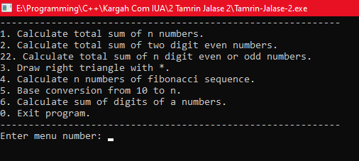

**جمع کردن تعداد نامشخص عدد**

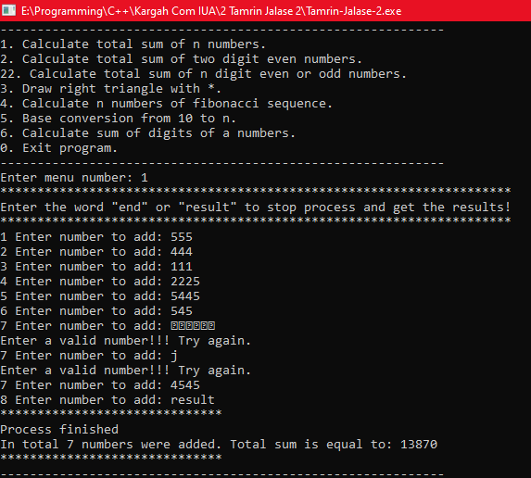

**.برنامه ای بنويسيد كه مجموع اعداد زوج دورقمي را محاسبه و چاپ نمايد.**

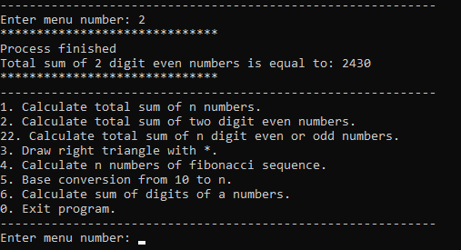

**مجموع اعداد زوج یا فردn رقمی**

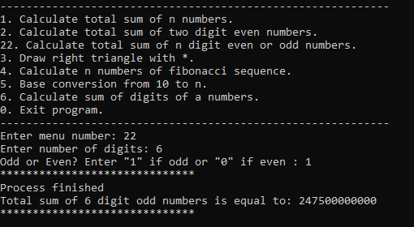

**مثلث با \***

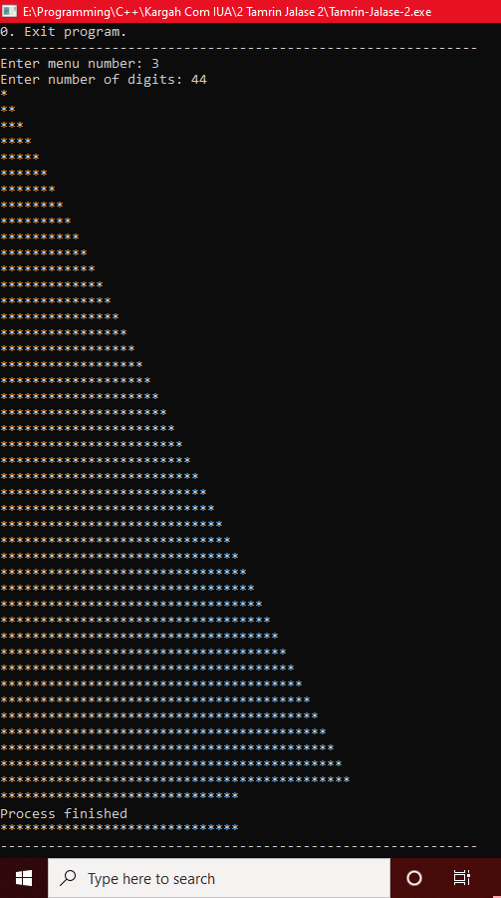

**سری فیبوناچی**

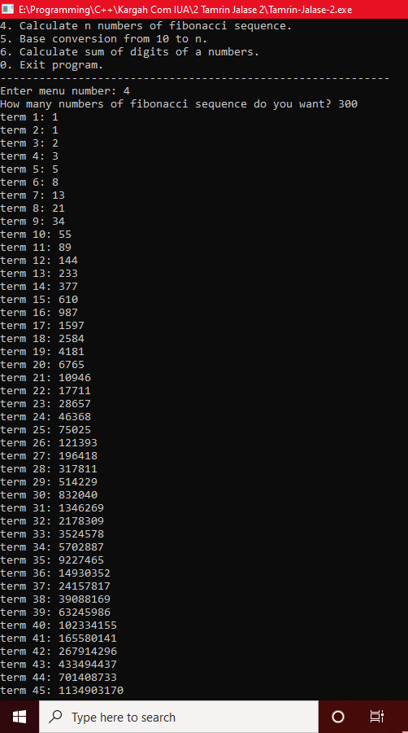

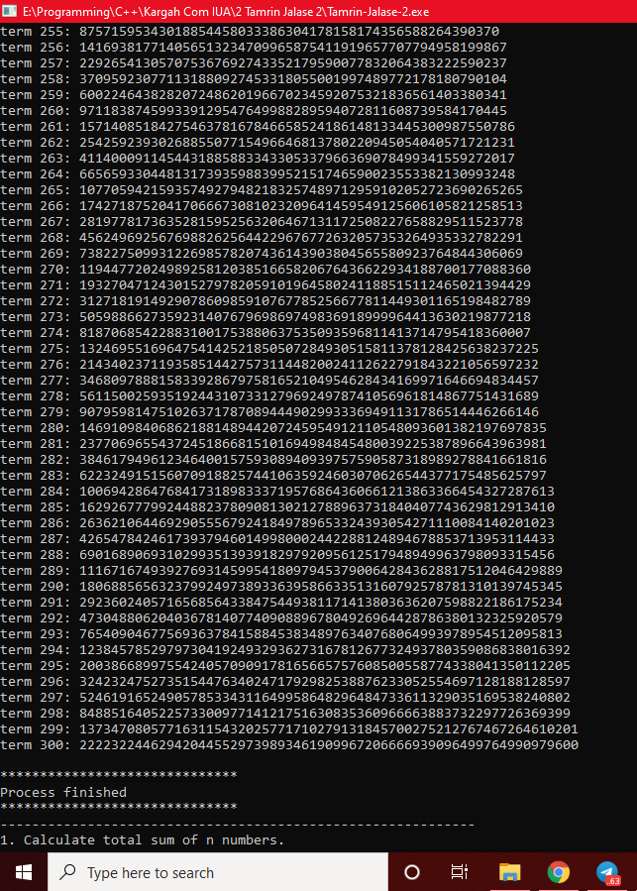

**تبدیل مبنا از 10 به n**

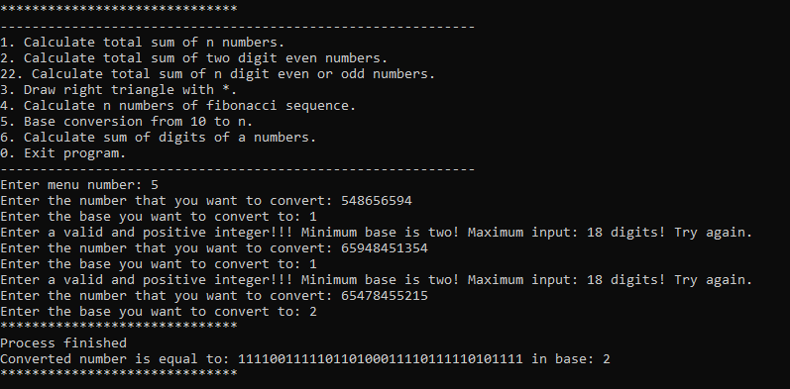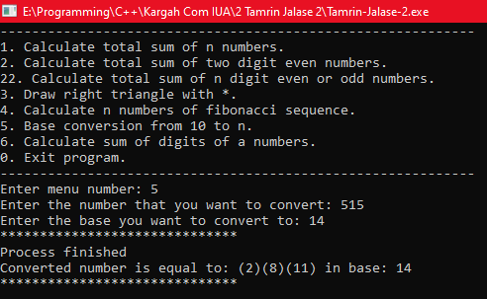

**مجموع ارقام عدد**

